Establishing the Single Sign-On Between Connect and Blackboard -
Student Registration Process

When students contact CXG for assistance with either registering for their Connect course through Blackboard, or attempting to complete Connect assignments through Blackboard, this request is considered as establishing the single-sign on (registration/pairing) between both Connect and Blackboard.

The following steps and screenshots will assist CXG agents with properly assisting students to complete the Single-Sign on process.
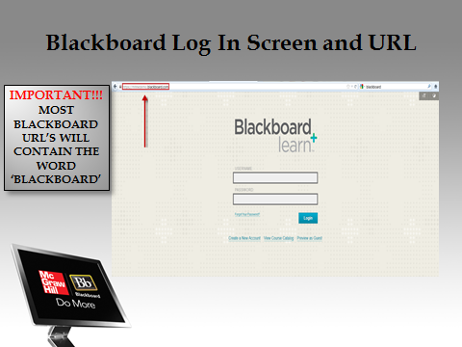
- Verify that the student is accessing their Blackboard accounts successfully. Students have several options of accessing their Blackboard accounts. Either through their school’s internal site by selecting a link which takes the student directly to their Blackboard course or the student can access their Blackboard course by visiting the unique Blackboard website which is provided to the student from the instructor.

- The log in page is requesting the username and password which are provided to the students. Please note: We will not be able to assist students/instructors with resetting their log in credentials for Blackboard using the Support Admin Tool. This feature is only allowed for Connect Enterprise users. If a student/instructor calls for assistance with resetting their log in credentials, please direct their attention to the Forget Your Password link located on the Blackboard log in page.
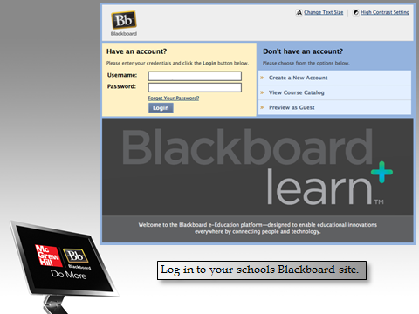
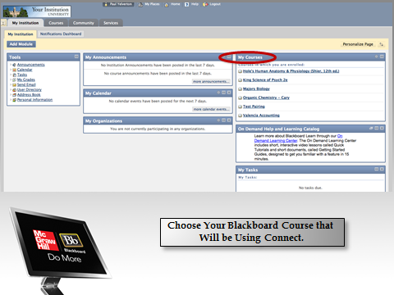
- Once the student has successfully logged into their Blackboard account, the student must select the My Course section. Within this section will be a list of course(s) provided by the instructor which are associated with Connect. The student must select the course associated with Connect to continue on with the registration process.

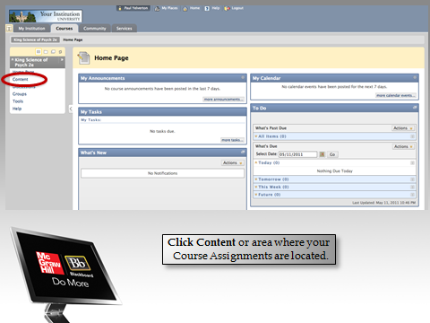
- Once the course has been selected, the student must locate the Navigation pane on the left side of the screen. Within this pane, the student is looking for key items which will direct the student to their assignments. Key items may include Content, Assignments, etc. Please note: Depending on how the school’s admin sets up the campuses Blackboard accounts, certain features may not be listed within the navigation pane. If this is the case, please be sure to ask the student probing questions like How do you access your assignments? Or, Which of the following links leads to your assignments? These forms of probing questions will eventually lead to accessing the student’s assignments successfully.

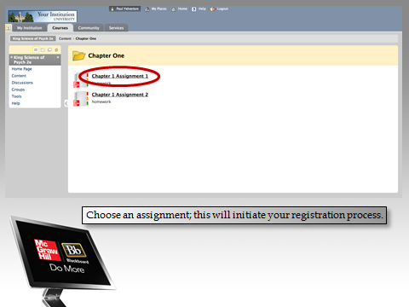
- Once the assignment has been located, the registration process begins. The logo may not always be attached to the assignment, so be sure to verify with the student which assignment(s) should be paired.

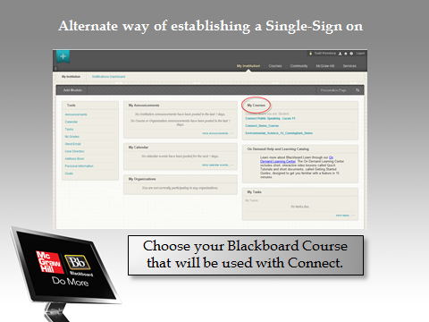
- Alternate way of establishing a Single-Sign on (registration/pairing) would be to select the My Course section within the students Blackboard account.

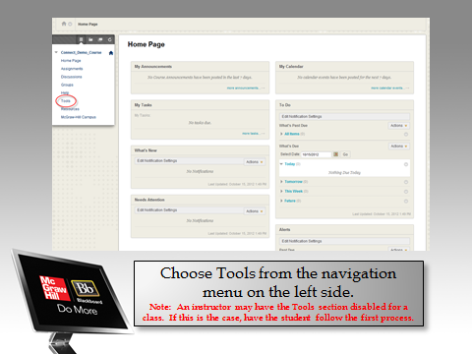
- Choose Tools from the navigation menu on the left side.
Please Note: An instructor may have the Tools section disabled for a class. If this is the case, have the student follow the first process.

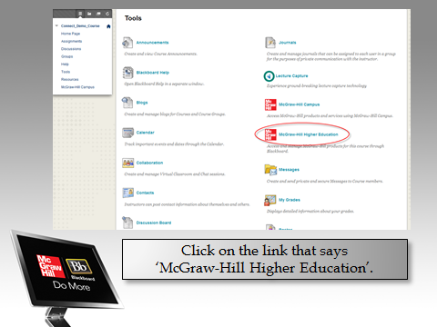
- By selecting the Tools link, the student is directed to the “back end” of Blackboard. The tools option provides several other options which are available for students use. However, our attention will be on the McGraw-Hill Higher Education link.

- The student must then select the Go To My Connect Section to complete the pairing process between Blackboard and Connect. 