Connect (SPARK)
Free Trial
Step 1: Navigate to the Instructor’s unique Section Website URL
Step 2: Click Register Now
Step 3: Enter e-mail address and click Submit (make sure it is correct)
Step 4: Click Start Free Trial (inform the student to keep track of the amount of time they have to use their free trial)
Step 5: Click Submit
Step 6: Fill in all of the fields and click Complete My Registration
Step 7: Click go to my course
You’re done!

NOTE: If registration expires, student will have to upgrade using a registration code or purchase access online with the SAME EMAIL ADDRESS used upon initial registration, to retrieve previous work.

Connect (SPARK)
Buy Online Option
Step 1: Navigate to the Instructor’s unique Section Website URL
Step 2: Click Register Now
Step 3: Enter e-mail address and click Submit (make sure it is correct)
Step 4: Click Buy Online (only credit / debit cards accepted using this option)
Step 5: Click Submit
Step 6: Select Country, State, School
Step 7: Select Purchase option (Connect or Connect PLUS)
Step 8: Keep track of when access expires (date will be shown at this point)
Step 9: Complete Profile
Step 10: Provide payment Information
Step 11: Proceed to complete registration

Connect (SPARK)
Self-Study
Website: http://connect.mcgraw-hill.com/selfstudy

Things to keep in mind:
- Free Trial is NOT available with Self Study option
- Self Study is NOT available for All Titles
- Registration Codes for Self Study look no different from regular codes
- Regular and PLUS codes are available
- If student purchases access to Self Study and the title is actually Not available:
Answer: The student should return the registration code to the place
of purchase

Known Issue: Connect Study accepting codes when the book is not available. ESCALATE if this happens.

Connect (SPARK)
Registration Codes
- A Connect registration code consists of 20 alpha-numeric characters. The code contains five sections of four characters each.

Example: DKH6-JK3H-AKFD-IAAW-F2CJ (Will not include O's or 0's).

- A Connect code can only be used once. After the code is redeemed, it is no longer valid. (Note: Once a code is used, it creates a license for a specific textbook)

- Good for either 180 or 360 days

- Plus Codes include eBook

- Chegg will offer McGraw-Hill Codes on their website beginning in August. You can research these codes in the Support Admin Tool (SAT)

- LearnSmart will have bundled codes (ex: four other components – Labs, Achieve, Smartbook and Prep).

- Registration Code Policy can be found in the Articles section: Example: CXG Training - Handout - Code Replacement Policy

- When generating a replacement code, it is always best to use the ISBN from the Connect Course URL Website.

  - Using Mozilla Firefox, right click on the image of the textbook on the instructor’s Course URL, select ‘view image info’ and retrieve ISBN as shown below:

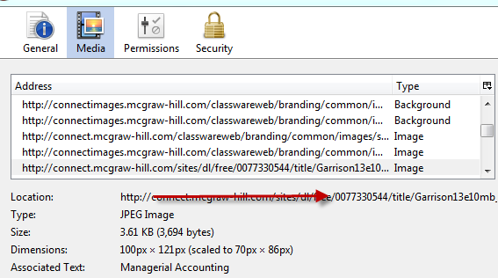

Connect (Spark)
Support Scenarios
Part 1: My computer froze during purchase
- Use Purchase Audit Tool in SAT to see if it shows a charge
Part 2: I forgot my password
- Use User Management Tool to reset password & send via Salesforce
- Encourage customer to reset it
- Never issue over the phone
Part 3: Code Replacement
- Determine if Registration Code should be replaced by using the Code Policy in Articles
- Use the Code Generation Tool in SAT when issuing a new code
Part 4: My Registration Code is Invalid
- Use Claim Code Search Tool to determine why the Registration Code is showing up as invalid
Part 5: Register Now button is unavailable
- Instructor set Registration to start and end date and it will not show until the course starts
Part 6: Prompt to upgrade when accessing the eBook
- Student has Connect only and not Connect PLUS
Part 7: I dropped the course and need a refund
- Check Code Replacement Policy to determine what to do
Part 8: How do I know if my computer will work with Connect?
- Use the Check My Computer (Compatibility Sniffer)
Part 9: Why is the Free Trial button missing?
- Free Trial Is Limited after 3 students access within a single week

Connect (Spark) Compatibility Sniffer
Checking System’s Compatibility

- Go to Connect Website: http://connect.mcgraw-hill.com
- Scroll all the way down to the bottom of page
- Discover and click on Technical Support
- Scroll down to Check My Computer located underneath Troubleshooting
- Click on Check My Computer
- Review your system’s compatibility

Connect (Spark) Private Offers
Article # 2404
See CXG Resources (select Private Offers)
What are some examples of a Private Offer within Connect?
- The length of Access length is different from the default
- The price is different
- Free trial option is disabled
- Where can I go to find information about a specific Private Offer?
- Google Docs via the Salesforce Article
  - Select CXG Resources
  - Private Offers
    - List of schools with Private Offers

Connect (Spark) Learning Solutions
Information listed under Learning Solutions
  - School
  - Site Name in Connect (This is not a Course URL)
  - Connect Course Area (Where the instructor can locate their custom course in Connect)
  - Author and Edition
  - What’s Custom? (Description of what was customized for the course)
  - National ISBN vs Custom ISBN
Note: If your customer is using a custom textbook, be sure to use the CUSTOM ISBN number in your Salesforce Case book information - not the National ISBN

Connect Enterprise Registration
Instructor Provides student the Boarding Pass URL:
Boarding Pass URL Example: https://connectenterprise.mcgraw-hill.com/class/CE174809811
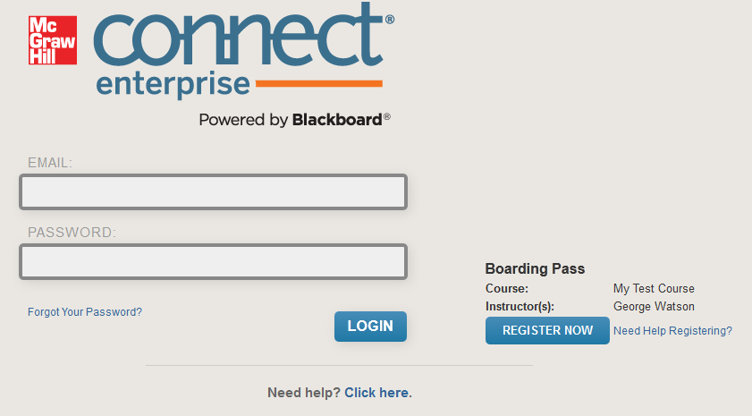
Student will take the following steps to register:
- Select Register Now
Student may receive the following message:

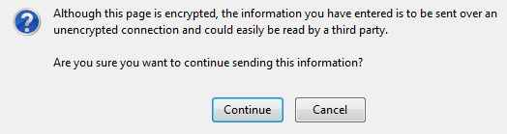
- Click Continue

- Enter Registration Code (as shown below)

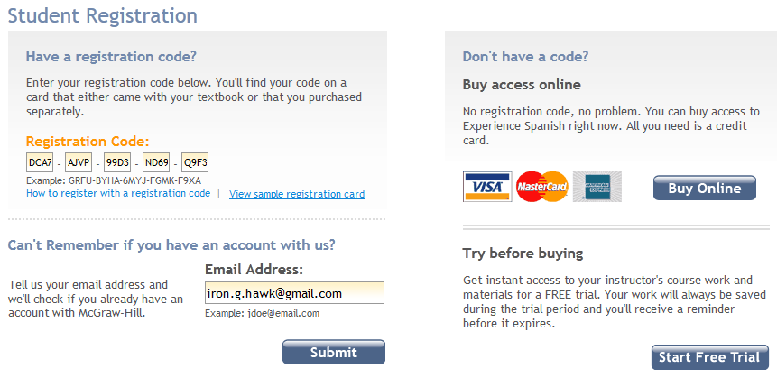

- Select “Go To Connect Enterprise” as shown below

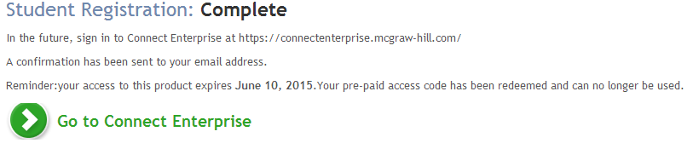

If Connect Enterprise is paired with Connect, the platform will look like this once the student login:
Hint: A book name is associated with the book Connect (Spark) is using when Connect Enterprise and Connect are paired.

If not paired with Connect, the platform will look like this once student login:
Hint: No book name is associated with the book Connect (Spark) is using when Connect Enterprise and Connect are not paired.

Connect English

Website URL: www.mhconnectenglish.com

Registration Code Examples:
- STUDENT
  - STDT-CCxx-xxxx-xxxx-xxxx
- INSTRUCTOR
  - INST-CCxx-xxxx-xxxx-xxxx

Section Codes:
- Provided by instructor
- Example: COMP123
- Case sensitive

Purchasing Option:
- No Online Purchase
- No Free Trial option
- Registration Code ONLY

Titles Available:
- Howard 1e
- Roen 1e

Support Tool:
- URL: www.mhconnectenglish.com
  - Username: mhcc
  - Password: support
Search by:
- First or Last name
- Email address
- Registration Code

Blackboard Registration & Single Sign-on
When students contact CXG for assistance with either registering for their Connect course through Blackboard, or attempting to complete Connect assignments through Blackboard, this request is considered as establishing the single-sign on (registration/pairing) between both Connect and Blackboard.

The following steps and screenshots will assist CXG agents with properly assisting students to complete the Single-Sign on process.
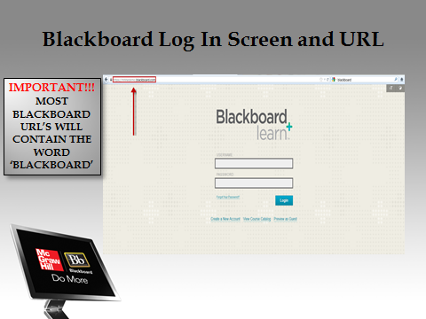
- Verify that the student is accessing their Blackboard accounts successfully. Students have several options of accessing their Blackboard accounts. Either through their school’s internal site by selecting a link which takes the student directly to their Blackboard course or the student can access their Blackboard course by visiting the unique Blackboard website which is provided to the student from the instructor.

- The log in page is requesting the username and password which are provided to the students. Please note: We will not be able to assist students/instructors with resetting their log in credentials for Blackboard using the Support Admin Tool. This feature is only allowed for Connect Enterprise users. If a student/instructor calls for assistance with resetting their log in credentials, please

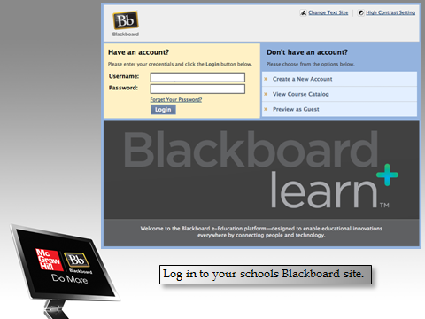
- direct their attention to the Forget Your Password link located on the Blackboard log in page.
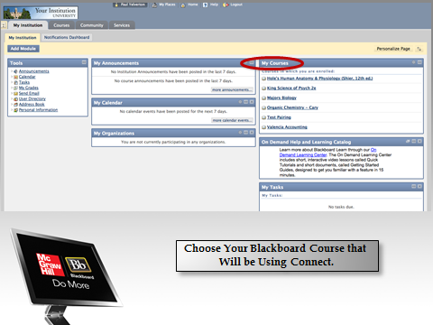
- Once the student has successfully logged into their Blackboard account, the student must select the My Course section. Within this section will be a list of course(s) provided by the instructor which are associated with Connect. The student must select the course associated with Connect to continue on with the registration process.
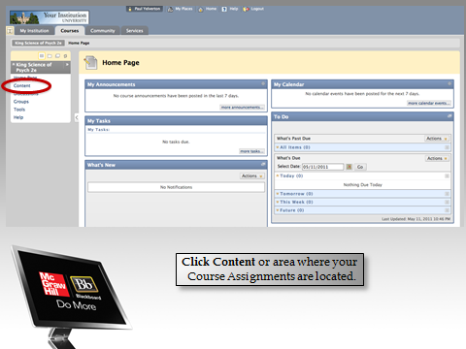
- Once the course has been selected, the student must locate the Navigation pane on the left side of the screen. Within this pane, the student is looking for key items which will direct the student to their assignments. Key items may include Content, Assignments, etc. Please

note: Depending on how the school’s admin sets up the campuses Blackboard accounts, certain features may not be listed within the navigation pane. If this is the case, please be sure to ask the student probing questions like How do you access your assignments? Or, Which of the following links leads to your assignments? These forms of probing questions will eventually lead to accessing the student’s assignments successfully.

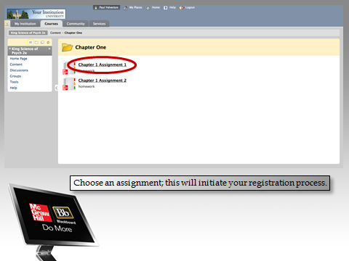
- Once the assignment has been located, the registration process begins. The logo may not always be attached to the assignment, so be sure to verify with the student which assignment(s) should be paired.

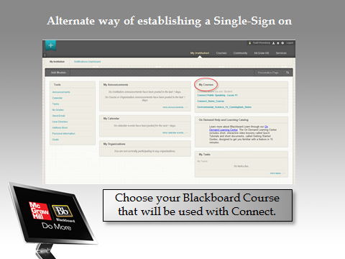
- Alternate way of establishing a Single-Sign on (registration/pairing) would be to select the My Course section within the students Blackboard account.

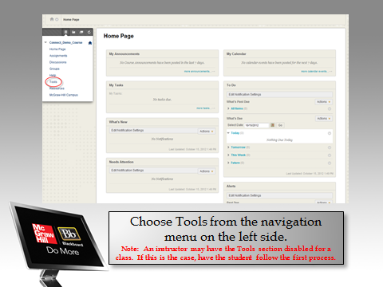
8. Choose Tools from the navigation menu on the left side.

Please Note: An instructor may have the Tools section disabled for a class. If this is the case, have the student follow the first process.

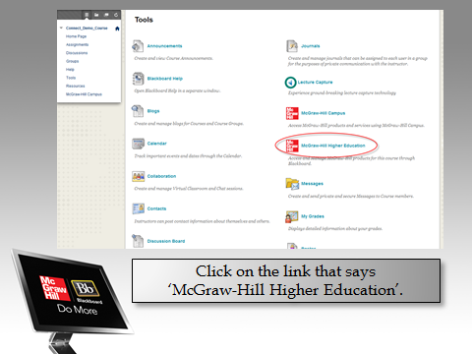

- By selecting the Tools link, the student is directed to the “back end” of Blackboard. The tools option provides several other options which are available for students use. However, our attention will be on the McGraw-Hill Higher Education link.

- The student must then select the Go To My Connect Section to complete the pairing process between Blackboard and Connect. 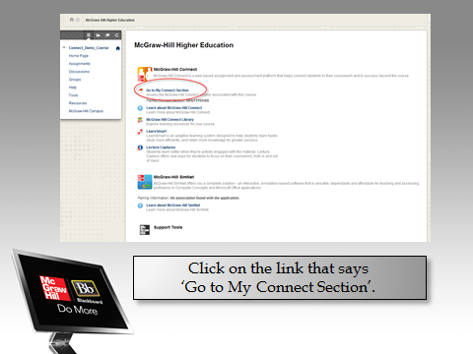

LearnSmart Registration

Website Address for Stand Alone: http://www.mhlearnsmart.com

Key features:

LearnSmart Stand Alone:

- Book-specific titles available
- Generic titles are available
- Students can use a registration code or purchase access online

Connect Integrated:

- Included in some titles (not available in all courses)
- No registration required
- Connect registration automatically provides students with access to LearnSmart

How can you tell which version a customer is using?

- By looking up the Registration Code in SAT
- How are they getting there (i.e., what is the website address?)
- Did student receive directions from instructor

LearnSmart Registration Regarding SmartBook Stand-Alone
With the recent release of Connect Release R7A, Learnsmart Advantage also launched SmartBook as a Stand-Alone platform in addition to being integrated into Connect Plus.
Below you will find the link to the LearnSmart Registration Training Video and

Presentation:
http://prezi.com/amsvvuodfjz6/tp-learnsmart-registration-5-31-13-tw/?auth_key=15b7b25a67f324a11a4a9874941cf10970e1ffc1
o This may take a few minutes to download
Feel free to review all of the slides and videos, but specifically view Slides 55 – 70 for the LearnSmart updated information.
This presentation outlines the difference between registering for LearnSmart Stand-Alone and SmartBook Stand-Alone.

Registering to LearnSmart Stand Alone:

Step 1: Navigate to Stand Alone
Step 2: Find Your Course (Red Button) or Buy/Sign-In Class (at top of
page)

Step 3: See list of courses to select from with various textbooks (to the left)
Step 4: Click Buy button (to right of text of choice)
Step 5: Enter Registration Code
Step 6: Type in email you will use to register
Step 7: Click Submit
Step 8: Create Account
Step 9: Enter Email, password, and first and last name
Step 10: Enter School Info
Step 11: Enter Security Question
Step 12: Click ‘I Accept’
Step 13: Click ‘Complete My Registration’
Step 14: Click link below
Step 15: Go into LearnSmart
Step 16: Sign In using Email and Password used to create account
NOTE:
- If the instructor is using LearnSmart Stand-Alone, they will provide the sign up code to the students.
- If a student would like to use their account as a self-study tool, they can simply choose a deadline for the semester (or any date).

“Try” Option to LearnSmart

Step 1: Navigate to http://mhlearnsmart.com

Step 2: Click on the "Buy/Sign into your Course" button in the upper-right
corner

Step 3: Click on "Economics" under All Courses

Step 4: Locate Economics: Brief Edition, Second Ed. (McConnell, et al.) 2e

Step 5: Click on “TRY"

Step 6: Once Learnsmart launches in another window, click on "Try it"

Step 7: Fill out Required information (email, password, first and last name)

Step 8: Click on "Yes, Please sign me up"

Step 9: Type in your name or you can click on "appear as anonymous",
then click "ok"

Step 10: If a pop-up video displays, then click "skip". Since your registration
is now successful, log out.

Step 11: Select a date in the calendar

Step 12: You should now see a list of chapters, and only chapters 3 and 4
are available to you

Access to Smartbook

- Through Connect PLUS
- Students using Connect Free Trial will have access to Smartbook for duration of trial
- Smartbook only available for certain titles

To Access
- Access LearnSmart Assignment within Connect
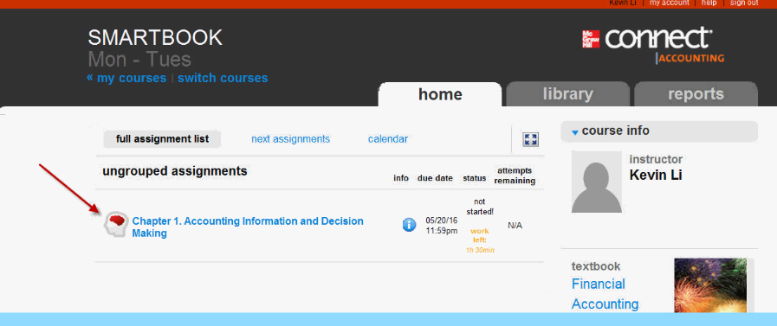
- See Smartbook option located at the top left in LearnSmart
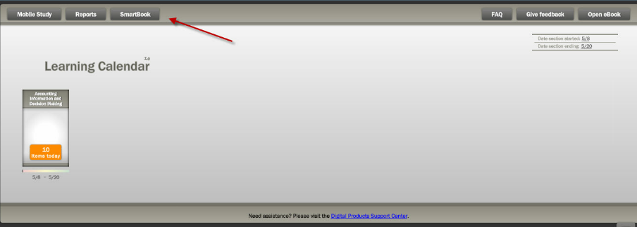

LearnSmart Advantage Registration
(Smartbook, Prep, LearnSmart, Achieve, Labs)
Step 1: Navigate to www.lsademo.com

Step 2: Scroll down and click on option (for example LearnSmart PREP)

Step 3: Click on "Get Access" on either discipline

Step 4: Click on "Sign-Up"

Step 5: Fill out the required information

Step 6: Select type as "student"

Step 7: Click "OK"

MH Campus Registration

MH Campus allows schools/institutions to use McGraw-Hill's Products with just a few clicks through their LMS (Learning Management Systems) a.k.a. a school's website.

Is MH Campus being used?

- Ask the customer how they are accessing their product. Some customers may not even realize that they are using MH Campus.

- Ask them to describe how they access the product to determine if they are accessing it via MH Campus or accessing it directly.

MH Campus Issue or Not
- If a customer is using MH Campus, it does not necessarily mean that the issue they are reporting is related to MH Campus.

- MH Campus acts as a bridge or gatekeeper (PARIS) between the LMS and MH products..

- Once the customer accesses their product successfully, any issue they experience is within the core product and not MH Campus.

- However, if a customer is having problems before they can access the core products, it is an issue with MH Campus

NOTE:

Student needs to select the correct option. If student selects “No, I am new to Connect” but in fact they already have an existing account student will need to contact CXG to have their account corrected. We will need to escalate to fix this issue.

If the student’s book does not show up in MH Campus most likely it is because the instructor did not set up the book or is not using MH Campus

MH Campus User Guides

The Support Website www.mhhe.com/support has user guides for the following platforms:

- Angel
- Blackboard
- Canvas
- Desire 2 Learn
- Moodle
- Sakai

Step 1:

To access the user guide, please scroll to bottom of website and select the McGraw-Hill Campus Resources: http://create.mcgraw-hill.com/wordpress-mu/success-academy/

Step 2:

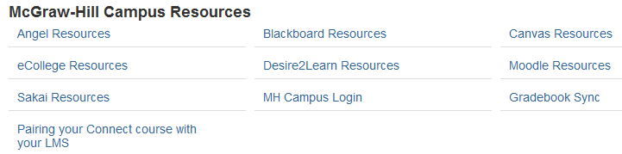

Troubleshooting Tool for MH Campus: http://goo.gl/bpmZP

MH Campus Article #’s:

- 3299
- 2864
- 2846
- 2847

Chegg Partnership
Article # 4428
Website URL: http://www.chegg.com

Chegg Presentation: http://prezi.com/4qmwl1qxxm8o/chegg-mhe-presentation-8-1-13-tw/?utm_campaign=share&utm_medium=copy
FAQs

- Students will have the option of purchasing access to LearnSmart standalone and/or a Connect registration code via Chegg’s website

- Chegg will manage all purchasing/refund requests (via their website). MH will continue to support all product related inquiries/issues related to registration

- SAT will allow agents to see which codes and purchases are made via Chegg

- Articles will be updated with a process matrix for Chegg supported issues

Start Date

- Connect Spark codes will begin being sold on Chegg's website as of August 8, 2013

- The tentative date for LearnSmart Advantage being available on Chegg is October 2013

Identifying a Chegg Purchase
*An agent can identify a purchase made from Chegg using the following in SAT

- Claim Code Search Tool: Next to the section labeled “System” Chegg will appear if the code is a Chegg Registration Code
- Purchase Audit Tool:
  - Verify a customer's purchase from Chegg via the Purchase Audit Tool
  - This option will only be available for LearnSmart (Advantage) products

  - Tentative date is October 2013
  - Only applies to LearnSmart Stand-Alone products

- User Management Tool: When viewing licenses, Chegg will appear if the code is a Chegg Registration Code under the section labeled “System”. If the registration code is a McGraw-Hill Registration Code and Not a Chegg Registration Code, MHE will appear under the word “System”.

Replacing a Registration Code:

- If you need to replace a code from a Chegg purchase, be sure to follow the existing Code Replacement Policy

- When generating a new registration code, it is important that a front-line agent select the appropriate System option (Chegg and/or MHE)

Chegg = replace a registration code purchased via Chegg’s website
MHE = replace a registration code purchased via MHE (packaged within a textbook)

Chegg Matrix
Article # 4428
Student Scenario | Chegg Process | MGH Process
Student's code not accepted on website, trouble registering with it. | 1. Walk through basic troubleshooting steps  2. If unable to register – Refer to MGH | 1. CXG front-line agent issues 1 code with required information
Student didn't receive code online | 1. Verify code in CSR or refer student to Account page  2. Walk them through registering their code  3. if unable to register walk though basic troubleshooting steps  4. If unable to register – Refer to MGH | 1. Cold Transfer to Chegg
Student dropped course and wants to reuse code (hasn't consumed code) | 1. Educate student that the code doesn't "activate" until they register it so they can just hold on to until they retake the course and activate then. | 1. Educate student that the code doesn't "activate" until they register it so they can just hold on to until they retake the course and activate then.
Student dropped course and wants to reuse code (consumed code but dropped class - so will expire before course retake & within 21 day refund timeline) | 1. Cancel the Access code (triggers an automatic refund)  2. Explain they need to repurchase when they retake the course. | 1. Cold Transfer to Chegg
Student dropped course and wants to reuse code (consumed code but dropped class - so will expire before course retake & outside 21 day refund timeline) | 1. Explain that since the code was already used and it is outside 21 day timeframe it cannot be refunded.  2. Explain they need to repurchase code when they retake the course.  3. If escalated  a. Cancel the Access code  b. Issue a 100% refund  c. Explain they need to repurchase when they retake the course. | 1. Cold Transfer to Chegg
Student purchased code for wrong product (inside 21 days) | 1. Cancel the Access Code (triggers an automatic refund)  2. Explain they need to repurchase code for correct product. | 1. Cold Transfer to Chegg
Student purchased code for wrong product (outside 21 days) | 1. Explain that it is outside 21 day timeframe and cannot be refunded.  2. If escalated  a. Cancel the Access code  b. Issue a 100% refund | 1. Cold Transfer to Chegg
Student dropped course and wants refund (inside 21 days) | 1. Cancel the Access Code (triggers an automatic refund) | 1. Cold Transfer to Chegg

Floor Help Process / Triage Process
Presentations

Floor Help Process

Presentation for TP: http://prezi.com/pb77jpthnw-n/tp-floor-help-process-updated-7-29-13-tw/

Step 1: Agent takes a call/Self Service Case
Step 2: Agent gathers and notes detailed information pertaining to the issue
Step 3: Agent checks CXG Resources
Ask yourself, “Is it a Known Issue?” If so, follows escalation process.
  - Check CXG Resources
  - Select CXG Updates
  - Review Case and Case Details

If you are able to address the issue

- Communicate the information in CXG Resources and close the case
- Document Case Comments with notes from spreadsheet

If the issue is not known

- Troubleshoot it
- Document steps you took to attempt to resolve the issue

Step 4: Contact your Supervisor (s/he will)
- Review the issue to determine if he/she is able to address
If Supervisor can resolve the issue

- s/he will provide next steps to you
If Supervisor cannot resolve the issue
Step 5: Supervisor contacts Floor Help (full support) agent for assistance (by phone)

Step 6: Floor Help (full support) agent records the request for tracking

If floor help can resolve the issue, s/he will

Step 7: Provide next steps to the Supervisor/Agent

If floor help cannot resolve the issue, s/he will

Step 8: Direct agent to follow escalation procedure

Step 9: Agent follows Escalation Process (Place case in CXG_Triage queue) but leave the Status as “In Progress”

Step 10: Follow up with the customer

Step 11: Agent then closes case

Triage Process

Presentation for TP: http://prezi.com/1pyt2cb78zpn/tp-triage-process-updated-7-29-13-tw/

Parent cases (Check to see if there is a parent case associated to the issue, prior to escalating the issue) Located in CXG Resources (in Google Docs)

Attach = Update case comments with all required information, change status to "escalated", add parent case, notify customer of escalation, and leave in your own name

Individual = Update case comments with all required information, change status to "in progress", add parent case, and escalate to the appropriate triage queue. Do not notify customer

NOTE: If there is any missing information, and you escalate your case to the Triage queue, that case will be returned to you with case comments in regards to what information is needed.

Step 1: Agent receives a support call or takes ownership of self service (email) case

Step 2: Agent troubleshoots issue and exhausts all resources (searches our Articles database, CXG Updates, SME's, Supervisors, and Floor Help) and is unable to resolve the issue

Please note: if you are unaware if the issue should be escalated please ask a SME or Supervisor

***Make sure to add the browsers used when troubleshooting the issue***

Step 3: Agent gathers detailed information pertaining to the support issue

Step 4: Agent adds a case comment with the required information for escalation (template from Articles)

Note: You can copy and paste the Escalation Article into the Case Comments section

Step 5: Agent assigns case to the CXG_Triage queue

Note: The case status is "In Progress" Status

Call Drivers, Case Examples & Articles #’s

Call Drivers | Articles | Case # Examples
"How To" Issues |  | 1465020
Registration Code Issues | Registration not valid or different issue with code 2161 | 1481765
Account (School) Issues |  | 1481404
Incorrect Credentials | Could be a regular us/pw issue or related to article 2304 | 1471536
Refund (eCommerce) Issues | Should contact customer service (877-833-5524) | 1464748
Private Offers for Connect | Article # 2404
Wrong Website Issues | Should refer to info received from instructor | 1529009
CNT: Free Trial | Article # 2359
CNT: Self Study | Self Study Questions & Article #'s
 | 1. Why am I unable to register for Self Study - 000001857
 | 2. Student registered to Self Study and now when they login, a message appears stating that they aren't enrolled in any section - 000002198
 | 3. If I register for Self Study, will I still be able to join my instructor's course later on? - 000001855
 | 4. Why did my Self Study section disappear when I registered for my instructor's course? - 000001856

